Chapter 2

Construction

Construction

2.1 Main parts:

The wind-cube divided into two parts the first one is the up-frame which consist of two frames (outer and inner) , the second part is base which carry up the generator chair and the up-frame and it must be fixed well because for sure it is installed at very high place and it's not allowed to be down .

2.1.1 The up-frame:

The inlet frame is a square 2m×2m and the thickness of the corner is 4 cm and the outlet frame is a circle with radius 0.5 m and thickness of 4 cm ,attached with tunnel with length 0.4 m and radius of 0.5 m , connects between them 4 support the slope of the venture is 45º ,The all parts of the wind-cube made of steel but we intended to make the venture of RFG (reinforced fiber glass)(but we it made of steel sheets of 1 mm because we didn’t afford fiber glass).

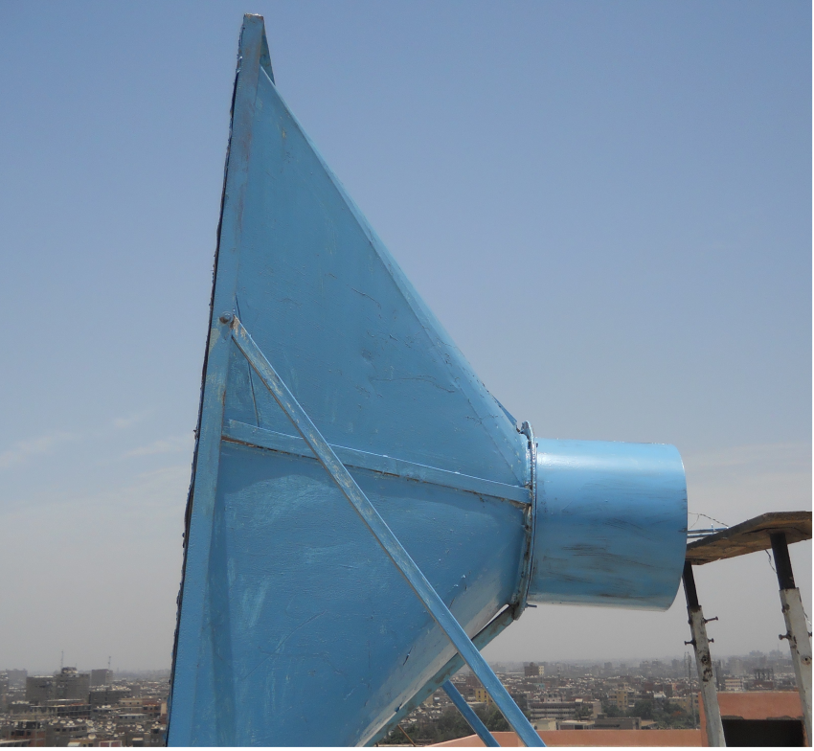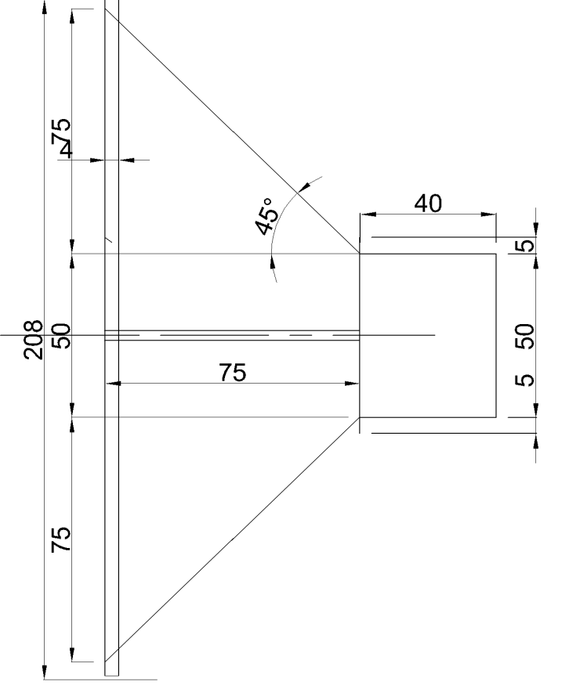

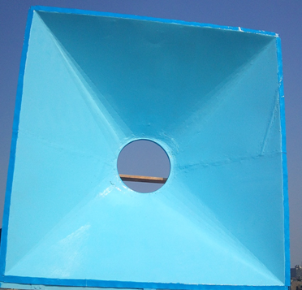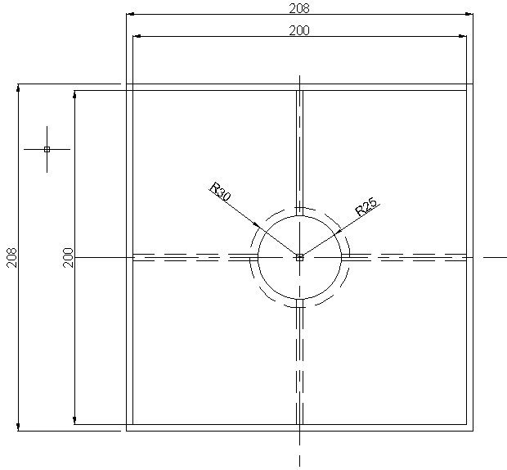

2.1.2 Nozzle smoothing:

When we made the nozzle we found that it isn't smooth so , we brushed it with polyster putty , then we removed the excess putty by Abrasive paper to make the air flows without any Hindrance.

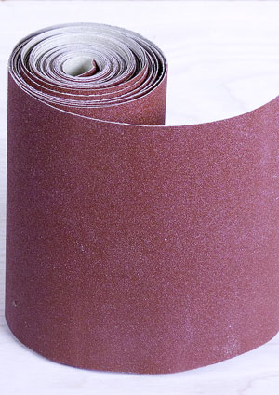

After smoothing we paint the all parts by anti-corrosive paint (primer) to avoid corrosion.

2.1.3 Generator chair:

to make the blades and the generator at the center of outlet of the nozzle we made a special construction for the generator chair that enables us to move the generator and the blades horizontally and vertically , the base which directly under the generator is from wood , connected to two legs , each leg consists of two square steel boxes ,

one box is 3cm×3cm which been put in other box of dimension 4 cm ×4cm , between them we put Greace to reduce the friction between them and facilitate the movement , and we control the length of the each leg by 3 pressing bolts , each leg fixed to the base by two bolts .

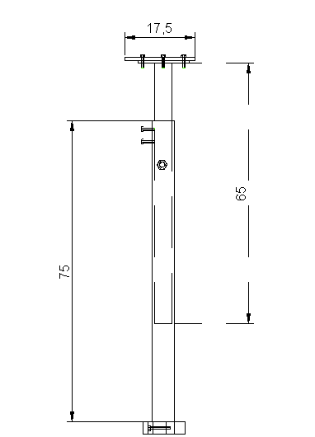
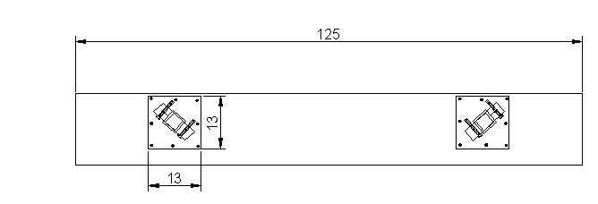

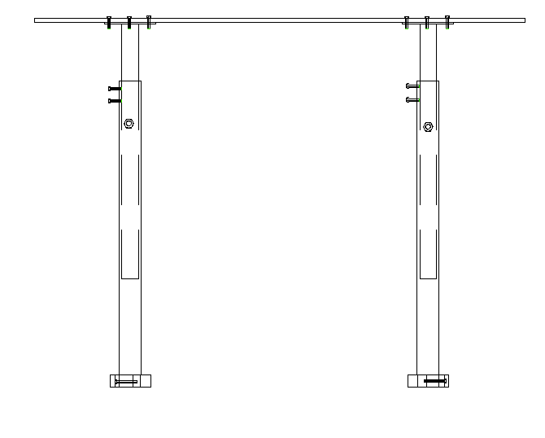

2.1.4 The base:

The base designed to bear the up-frame and the generator chair and also have the availability of rotation (as wind direction is variable).

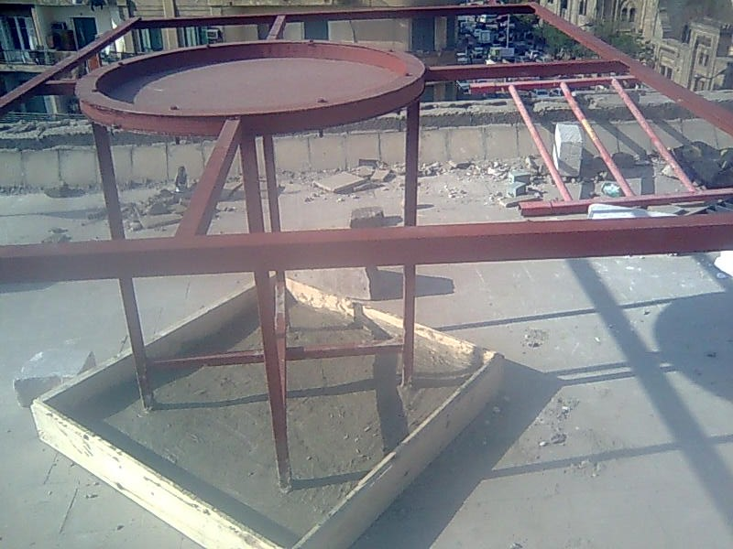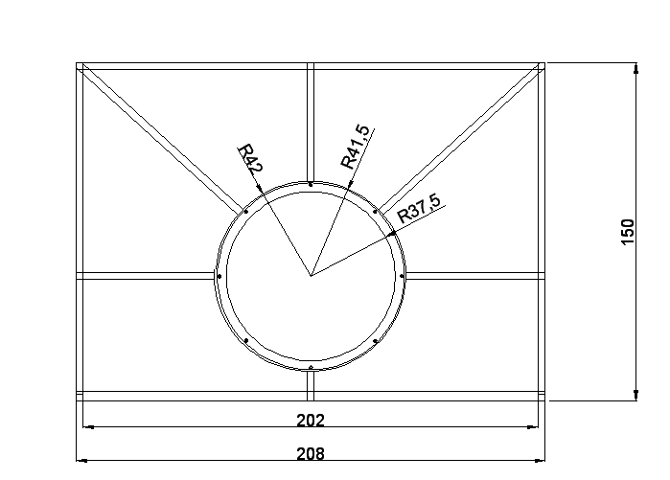

It has Four moving legs at each corner, each leg has a wheel on it's end

and has Four fixed legs at it's middle , each leg is fixed well with two bolts and the all Four legs is in a concert container of area 1m ×1 m and it's height 10 cm , the 4 legs is connected together with 2 supports .

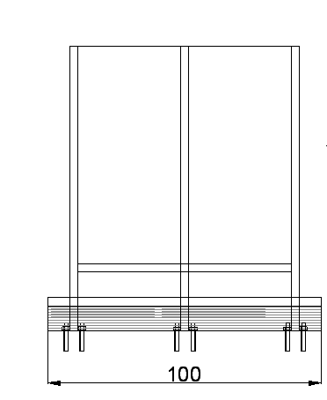

The legs connects with the base body by welding .

Movement of the base:22.

The outer frame of the base which is 1.5m × 2 m connects to a ring of diameter 84 cm with 6 supports by welding , inside this ring there is a collar of diameter 83 cm which is fixed with the base body with 8 bolts 8mm , and between them there is a grease , above them there is another ring which is fixed with the collar with the bolts.

Connection between nozzle and base:2.3

4 bolts connects between nozzle and base which is put as on the figure , also there is two supports where one side connects to the nozzle by welding and the other side connects to the base by welding.

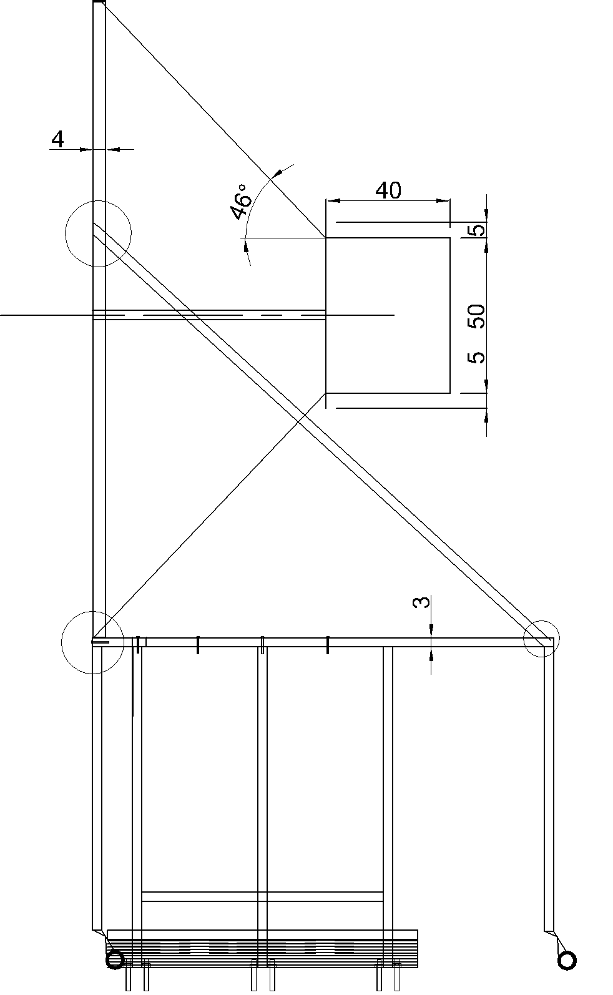

2.4 The complete construction:
